Summer Transition Booklet
Art & Design

Year 6 into Year 7
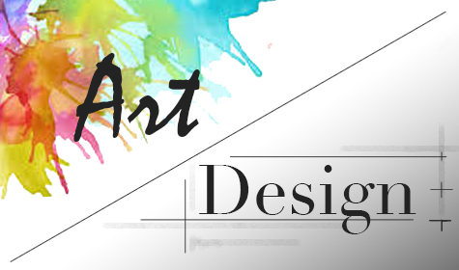

Name: ______________________________

Welcome Message:
Here is a message from the Head of Art and Design:
My name is Mrs Beveridge and I am Head of Art & Design here at Dean Trust Ardwick.
Here in the Art & Design faculty, we cannot wait to welcome you all in September and get your creativity flowing! During your time in Art & Design at DTA, you will learn about many different artists and art movements and develop your creative thinking skills such as researching, designing and making. You will also have the opportunity to learn many new practical skills including drawing, painting and 3D modelling.
And…If you want to develop your Art skills even further why not join one of our Key Stage 3 after school Art clubs. We look forward to seeing you!
Have a great summer, from the Art Teachers at DTA!

Our recommendations to you:
To improve your art skills, you need to draw regularly: here are some ideas of how to brush up your art skills before, during and after year 7.
- Practice sketching and always use a really sharp pencil.
- Draw real objects that are in front of you, e.g. a piece of fruit or 3D shape.
- Practice shading with your pencil.
- Practice blending with your pencil crayons.
- Try to create different textures with your pencil.
- Watch YouTube Videos. These will really help you to improve.
You may have already heard of ‘Draw with Rob’ on YouTube.
If not, have a go at one of his videos. They are great!
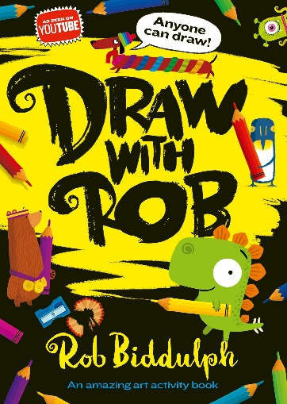

30 Day Art & Design Challenge
Over the summer holidays why not have a go at the 30-day art challenge below! How many can you do?
Tick them off as you go along…

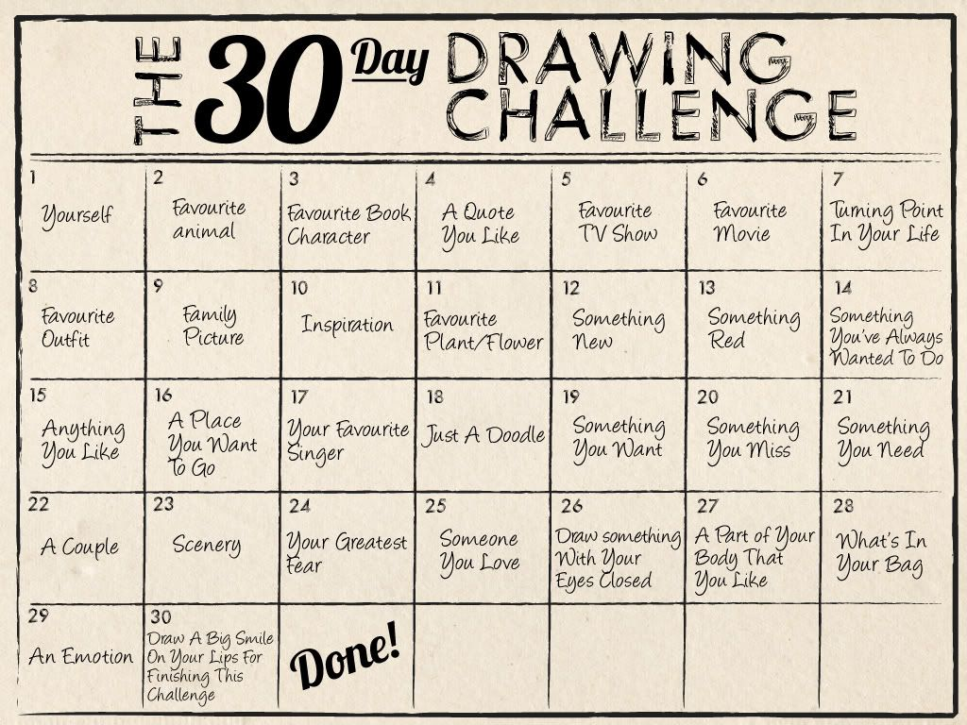

Year 7 Art and Design Questionnaire
Full name _________________________________________ Form _____________________
My last school was _________________________________________________________________
My favourite subject/s are ___________________________________________________________
What are the 3 primary colours? ________________ + _________________ + _________________
What type colour do you get when you mix the 3 primary colours together? __________________
How do you mix the 3 secondary colours? Purple _________________ + _____________________
Orange _________________ + _____________________
Green __________________ + _____________________
Have you drawn from real objects or people that are in front of you? Yes___ or No___
List the things you liked or drew the best? ______________________________________
Tick or highlight any of the media, materials and techniques you have used before.
Coloured pencils | Graphite | Collage
Biro / ball point pen | Watercolour paint | Tissue paper
Fine liner / felt tips | Acrylic paint | Mosaic
Chalk / pastels | Poster paint / gouache | Wire
Oil pastels | Paper mache | Cardboard
Wax crayons | Clay | Withies
Charcoal | Plaster

Explain the best piece of Art and Design work you have made in or out of school?
_____________________________________________________________________________________________________________________________________________________________________
What did you enjoy most about making this piece of Art work?
_________________________________________________________________________________--____________________________________________________________________________________________________________________________________________________________________
List the names of any artists, designers, sculptors, craftspeople or cultures that you have learnt about in art? ______________________________________________________________________
What type of art work do they do and what you know about them?
__________________________________________________________________________________________________________________________________________________________________________________________________________________________________________________________________________________________________________________________________________________________________________________________________________________________
What sort of Art, Craft and Design work do you do at home? ______________________________________________________________________________________________________________________________________________________________________________________________________________________________________________________
Does anybody in your family have a job that involves Art, Craft or Design? Or as a hobby?
If yes, explain what they do? _________________________________________________________
Name the 7 colours of the rainbow? (Challenge In order?) __________________________________ ____________________________________________________________________________________________________________________________________________________________________
Explain what complementary colours are? ________________________________________________________________________________________
List the 3 pairs of colours? ____________________ + ___________________
____________________ + ___________________
____________________ + ___________________
Have you ever drawn from memory or using your imagination? If yes, explain? __________________________________________________________________________________
What Computer programmes, app or games have you used to make Art, Craft and Design work at home or in school?
_________________________________________________________________________________
Do you have access to a computer and printer at home?
_________________________________________________________________________________
What do you really like about Art, Craft and Design? ______________________________________________________________________________________________________________________________________________________________________________________________________________________________________________________
If you had a choice what would you really like to do as a project or homework for Art?
____________________________________________________________________________________________________________________________________________________________________
What would you really like to learn about in Art and Design? Or what would you like to improve?

_________________________________________________________________________________

Task:
In the box below draw a piece of fruit or vegetable and shade it in using a pencil.
Tips:
- Use a sharp pencil
- Sketch, press on lightly
- Draw it the same size
- Copy all of the detail
- Shade it in using pencil
- Include the shadows

