Summer Transition Booklet –
Computer Science

Year 6 into Year 7

Name: _________________

Welcome Message:
Welcome to your Computer Science Summer Work Class of 2027! We are very excited to welcome you to study Computer Science at Dean Trust Ardwick and learn about how the computers work, online safety and coding! Hopefully you will want to get involved with some extracurricular activities as well.
Here is a message from the Head of English:
My name Mr Martin and I am Head of IT at Dean Trust Ardwick. I am very much looking forward to welcoming you all to Computer Science in September.

Computer Science has many areas to cover and such a wide variety of topics that you will cover throughout your time at Dean Trust Ardwick. You can begin to look at some of these areas by looking at the apps or websites shown below.

Enjoy your summer break and see you all in September!

App/Website recommedations for you:
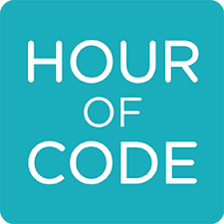

Scratch Lightbot Hour of Code

Memory
Introduction
Memory is where binary data (0s and 1s) is stored. There are several devices in a modern computer which store data. They store this data in different ways and for different purposes. We shall now take a look at each type of memory device:
- RAM
- ROM
- Virtual Memory
RAM Random Access Memory – AKA Main Memory
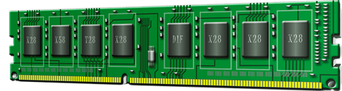
RAM is needed to store programs that are currently being used. They help to enable ‘multi-tasking’, which means having several programs open and using them all at the same time. It does this by copying the data needed by programs at that time so that it can be passed to the CPU when it needs to process that data. It also stores all the instructions/modules from the open programs that the CPU will require for processing.
RAM stores data as small charges of electricity in tiny transistors etched into a circuit in the device. The charge needs to be refreshed every few milliseconds otherwise the charge leaks away. RAM is therefore volatile memory – it loses data when there is no power.
When programs are opened by the user, they are loaded from the hard disk onto the RAM. This is so that the CPU can access the data and instructions at an acceptable rate. If the CPU reads the program instructions and data from a hard disk, the data access would be extremely slow – this is why RAM is so important.
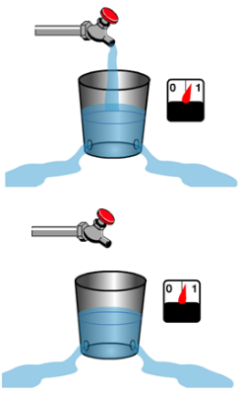
How does RAM store data?
Ram holds data using capacitors and transistors. A capacitor can be thought of as a sink or bucket holding water. When it is full it’s holding a ‘bit’ of data (1), when it is empty it represents a zero (0). But obviously in RAM it holds an electrical current (not water). The transistor acts as a switch that lets the computer read the what is in the capacitor (bucket) or fill it up or empty it (change its state).
How Capacitors and Transistors Work – a brief overview!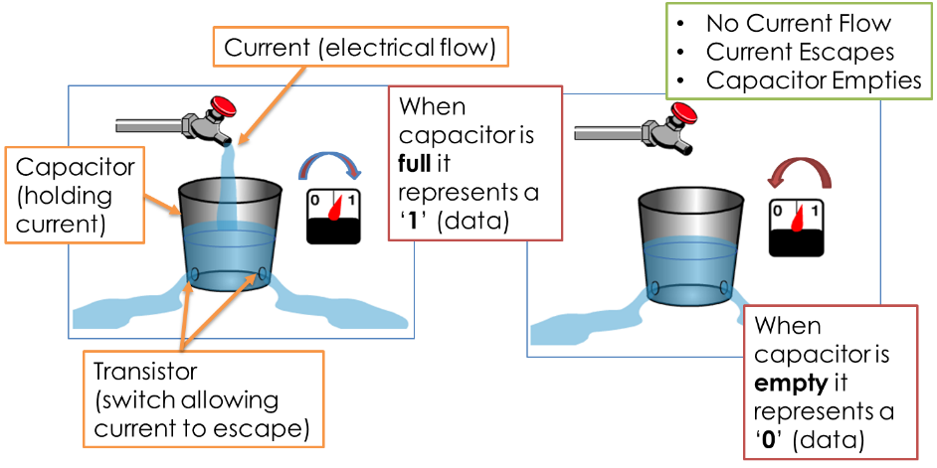
How the amount of RAM affects performance
So as we’ve just seen, RAM is needed to supply to the CPU with data and instructions from programs currently in use and when it gets full, the system runs slower as a result of the need to use virtual memory. Therefore the following is true:
- Smaller amounts of RAM – limited multi-tasking and greater need to use slower virtual memory
- Larger amounts of RAM – greater storage of programs / data leading to faster performance and effective multi-tasking.

Questions

- State the difference between ‘volatile’ and ‘non-volatile’ memory. [2]
- Describe the purpose of RAM and ROM. [2]
- What is virtual memory and why is it important. [3]

Mind Map activity
Create a mind map on RAM. It must cover at the least the following:-
- What RAM stands for
- What it is
- How it works

