Summer Transition Booklet –
English

Year 6 into Year 7
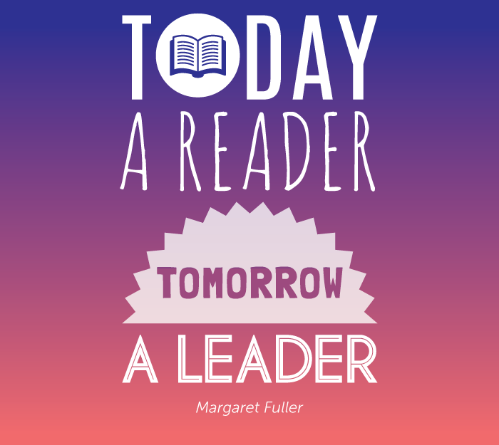

Name: _________________

Welcome Message:
Welcome to your English Summer Work Class of 2027! We are very excited to welcome you to our school in September! In this pack you will find 6 activities to complete over the 6 weeks of the Summer Holidays. It will help you to learn some key vocabulary that will give you a flying start when you join us in September. Please hand this in to your class teacher when you start.
Here is a message from the Head of English:
My name is Miss Horsley and I am an English teacher here at Dean Trust Ardwick. I am very much looking forward to meeting you all in September. The best thing you can do to prepare over the Summer is to read as much as you can! I recommend joining your local library and finding your new favourite book. My favourite books are anything by Roald Dahl – you have probably read some of his books for younger children, but have you ever read his adult short stories? I also love to read Dystopian Fiction- books that show the world in a different way and make us think about things! “Noughts and Crosses” by Malorie Blackman is fantastic! Also, you’ve probably heard of Frankenstein’s monster, but have you ever read the text!? This is a spooky story about science and the dangers of ambition!

Our recommedations to you:
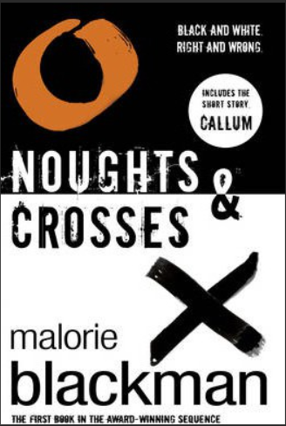
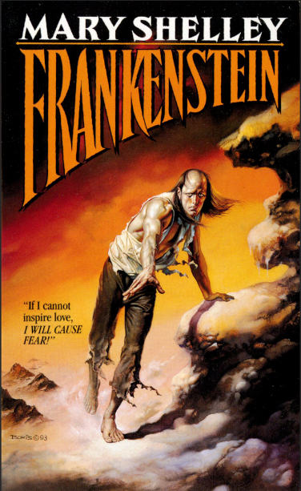
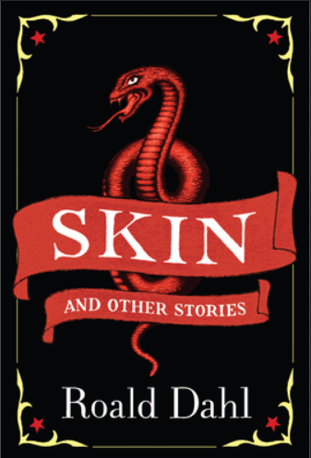

Contents:

Week | Task | Completed
1 | Root words-  Prefixes and suffixes
2 | Etymology
3 | Plot - reading
4 | Plot - writing
5 | Character - heroes
6 | Character - villains

Week 1: Etymology and root words
Challenging question: What are root words, prefixes and suffixes?

Do now: Can you change these verbs to past and present tense.
Verb = an action (doing word)

Root verb | Present tense | Past tense
run | running | ran
bake | baking | baked
swim
talk
rain
jump

What are root words?
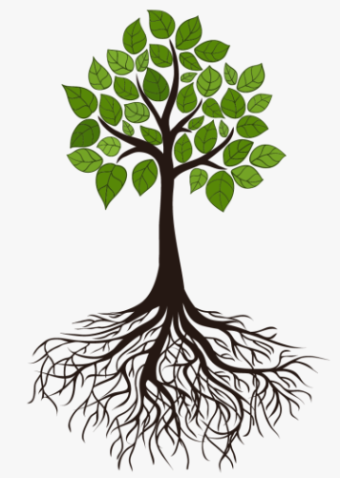
A root word is the most basic form of a word. This is the part of the word that contains the meaning, or tells you what action is being done.
As soon as you start to change the ending of the word, you change the tense.
Think about it like this: a tree cannot live and grow without its roots, just like a word cannot survive without its root.

For example:
Root word +ing +ed +tion
act acting acted action

What are prefixes and suffixes?
When we add letters to the start of a word, this is called a prefix.
When we add letters to the end of a word, this is called a suffix.

Pre- = from the Latin word [prae-] meaning before
Challenge: Can you think of any other words beginning with the prefix “pre”?

precaution | preschool | prepare | prejudice | precede

Task 1: Underline the prefix in each word.

- Illegal 6. Recycle
- Misunderstand 7. deconstruct
- Unnecessary 8. antibacterial
- Dissatisfied 9. antisocial
- Autobiography 10. Unhappy

Task 2: How many words can you make with the following prefixes?
Un+ | Dis+ | Auto+ | Tele+
unnatural | disguise | automobile | telegram

How can I add suffixes to root words?
When you add a suffix to the end of a root word, this usually changes the tense.
For example = celebrate +ed = celebrated

Task 3: Change the tense of these root words by adding the following suffixes.
Root word | +ed | +ing | +ion
act | acted | acting | action
distract
educate
affect
create

Task 4: Read the passage on coal-tips. Underline any prefixes or suffixes.
Heavy rainfall and flooding are the main causes.
The annual rainfall in Wales has increased as a result of climate change.
Coal tips are primarily composed of stone and other discarded material from mining operations. This material is stacked on top of each other, and combined to form a coal tip.
South Wales' heavy mining history has left it with many left over coal tips. The terrain largely consists of many steep-sided valleys. Such conditions make these tips more susceptible to collapse when exposed to heavy rainfall.
Geologist Dr Jamie Price says longer and more intense rainfall increases tip slide risk.
Geologist Dr Jamie Price explained: "Both more prolonged and more intense rainfall events will heighten the risk of coal tip collapses.
"Increases in the moisture content of the coal tips and increases in groundwater level in general can affect the stability of these coal tips and could induce failure and collapsing of the coal tips."
Ms Williams has called for some of the coal tips to be removed entirely, while others to be monitored constantly.
Week 2: Etymology
Challenging question: How can I explore where words in the English language come from?

Do now: What does the word “school” make you think of?

School

Did you know…?
The word “school” is derived from the Ancient Greek word [schole] meaning leisure, or a group to whom lectures are given. The Ancient Greeks were big thinkers and basically invented the concept of schools and classrooms.
In fact, the Ancient Greeks were also the founding fathers of modern medicine. Doctors today still have to take the Hippocratic Oath.
Hippocratic Oath = a code of ethical practice sworn to by doctors. Invented by the Greek thinker, Hippocrates.
This is why so many of our medical words come from Ancient Greek or Latin!
Hygiene = from Hygeia, the Ancient Greek goddess of health.
Biology = from Bios, meaning life
Paediatrics = Children’s medicine, from ped- meaning child.
Pneumonia = from pneuma, meaning breath
Psychology = from the Greek Psyche, the Ancient Greek goddess of the soul

What is etymology?
Etymology means the study of the history of words and how they have originated.
Etymology
[Etymon = Ancient Greek for root word] [-ology = the study of]
Challenge: How many other words can you think of, ending with the suffix -ology?

Task 1: Can you work out the meanings of these English words based on their etymology?
Word | Etymology | Meaning
Anthropology | From the Latin [bi] or [bis] meaning “two.”
Cyclops | From the Greek [circle] meaning “round” and [ops] meaning “eye.”
Melancholy | From the Ancient Greek [melaine chole] meaning “black bile.” If you had too much black bile in your body, this was said to make you sick, unhappy, or depressed.
Anthropology | From the Latin [Anthropos] meaning “human” and [ology] meaning “study of.”
Biscuit | A French word, from the Latin [bis] meaning “twice” and the French [cuit] meaning “baked.”
Why do so many English words come from French?
England shares a channel with France. But this is not the only thing our two countries share! Many English words have been borrowed by the French. This is because the Normans invaded England in 1066 and the English nobility were forced to speak French!
Examples of words we have “borrowed” from the French:
Beautiful = from the French beau meaning handsome.
Blank = from the French blanc, meaning white.
Chef = from the French chef de cuisine, meaning head or “chief” of the kitchen.
Perfume = from the French parfum, meaning pleasant-smelling.
Toilet = from the French toilette, meaning a bag for clothes.
Challenge: Can you guess why so many of our “French” words are to do with fashion or food?
________________________________________________________________________________________________________________________________
Why do most of our French words sound so “fancy”?
This is because French was the language spoken by the nobility. The peasants still spoke in Old English. In fact, this is how so many swearwords in English originated, as common English words grew to seem coarse or vulgar.
You will find that many “common” Old English words have a more elevated French equivalent.
Old English | French
Smell  Ghost  Buy  Drink  Wild  Grave/graveyard  Snake  House  Belly  Ask | Odour  Phantom  Purchase  Beverage  Savage  Tomb/cemetery  Serpent  Mansion  Stomach  Enquire

The French had an influence on food, culture and the arts, in the same way the Ancient Greeks and Romans had an influence on science and medicine.
In contrast, most of our common, every day words originate from Old English.
Etymology-  Old English | Etymology-  French | Etymology-  Ancient Greek/Latin
Pig  Beer  Church  Apple  Knight | Fashion  Bachelor  Poetry  History  Etiquette | Pandemic  Pharmacy  Veterinary  Medicine  Neurology

Task 2: Read the extract from Le Grand Meaulnes by the French novelist Alain-Fournier (1913). The narrator, a teenage boy called Francois, is describing his house (maison) in rural France.
Highlight/underline any new vocabulary.
A long red house, with five glazed doors, shrouded in Virginia creeper, at the far end of the little town; a huge courtyard with shelters and washing places, which opened at the front towards the village through a large gateway; on the north side, the road beyond a little barred gate leading to the railway station, three kilometres away; to the south and at the back, fields, gardens and meadows with the outskirts of town beyond them... There you have a sketch plan of the dwelling in which the most poignant and anguished days of my life were spent, the dwelling where our adventures ebbed and flowed, breaking like waves on a solitary rock…

Word | Etymology | Definition
Virginia creeper | From the Greek meaning virgin ivy. | A type of ivy  (a creeping plant).
Use a dictionary or online dictionary to find the meanings of any new vocabulary.
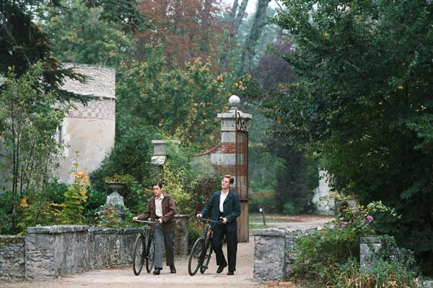

From the film adaptation of Le Grand Meaulnes, (1967)

Week 3: Plot - Reading
Challenging question: How are the plots of most stories structured?

Do now: Image you are baking a cake. Number these steps in order.
Mix all of the ingredients together.
Weigh out all of the ingredients.
Serve and enjoy!
Crack the eggs.
Put the cake in the oven to bake.

Well, structuring a story is a lot like baking a cake. You need to have the right ingredients and you need to put them in the right order – otherwise your story will turn out to be a mess!

Freytag, a Germany playwright, came up with a generic plot structure which works for most stories. This is called Freytag’s pyramid:
4. Climax
3. Rising action
- Exposition (set up)
2. Catalyst/
Inciting incident
5. Resolution

How does the Five Act Structure work?
Most stories are divided into these five acts, or parts. Let’s take a well-known story, for example Cinderella…
Act | Definition | Example
- Exposition (set up) | The hero and their everyday world is explored. The hero always has a problem which needs fixing. | Cinderella is forced to cook and clean for her wicked stepmother and ugly stepsisters.
- Catalyst/ inciting incident | Something happens to the hero, which sets them off on their journey of discovering. This is the point that gets the story rolling! | Prince Charming announces that he is throwing a ball and inviting all illegible maidens in the kingdom to attend.
- Rising action | Tension starts to heat up, at the protagonist encounters obstacles along their journey. | The Fairy Godmother puts a spell on Cinderella – but the spell begins to wear off at midnight.
- Climax | The highest point of action in the story: the hero goes head-to-head with the antagonist or antagonistic force. | Cinderella rushes home from the ball – leaving one of her glass slippers behind!
- Resolution | The story is resolved. The character and the world are both changed for the better. | The Prince tries the shoe on every maiden in the kingdom, until it fits Cinderella’s foot. They live happily ever after.

Protagonist = the main character, or hero, in a story.
Antagonist = the villain, or character who causes conflict for the protagonist.
1  2  3  4  5  6  7  8  9  10  11  12  13  14  15  16  17  18  19  20  21  22  23  24 |  | The Great Mouse Plot, By Roald Dahl.  Task: Read the short story, ‘The Great Mouse Plot,’ by Roald Dahl. Describe what happens in each act of the story.  Her name was Mrs. Pratchett. She was a small, skinny old hag with a moustache on her upper lip and a mouth as sour as a green gooseberry. She never smiled. She never greeted us when we came in. The only times she spoke was when she said things like, “I’m watching you, so keep your thieving fingers off them chocolates,” or, “I don’t want you here just looking around. Either you forks out you get out.”  But by far the most loathsome thing about Mrs. Pratchett was the filth that clung around her. Her apron was gray and greasy. Her blouse had bits of breakfast all over it, toast crumbs and tea stains and splotches of dried egg yolk. It was her hands, however, that disturbed me the most. They were disgusting. They were black with dirt and grime. They looked as though they had been putting black ink into pens all day long. And it was those very hands and fingers that were putting our lollies into packets or holding our ice cream cones (she never used a tissue). She had never heard of the health laws and, as hers was the only shop around where we lived, we had no choice but to go there when we had a craving for something sweet, like Coke bottles or Jelly Beans or Jet Planes. The mere sight of her grimy right hand with its black fingernails digging into a jar of wine gums would have caused a starving tramp to go running from the shop. But not us.  Sweets were our lifeblood. We would have put up with far worse to get them. We simply stood and watched in sullen silence while this disgusting old woman stirred around inside the jars with her foul fingers.  …….  My four friends and I had come across a loose floorboard at the back of the classroom, and when we prised it up with the blade of a pocket-knife, we discovered a big hollow space underneath. This, we decided, would be our secret hiding place for sweets and other small treasures such as conkers and monkey-nuts and birds' eggs. Every afternoon, when the last lesson was over, the five of us would wait until the classroom had emptied, then we would lift up the floor-board and examine our secret hoard, perhaps adding to it or taking something away.  One day, when we lifted it up, we found a dead mouse lying among our treasures. It was an exciting discovery. Thwaites took it out by its tail and waved it in front of our faces. 'What shall we do with it?' he cried.  'It stinks!' someone shouted. 'Throw it out of the window quick!'  'Hold on a tick,' I said. 'Don't throw it away.'  Thwaites hesitated. They all looked at me.  When writing about oneself, one must strive to be truthful. Truth is more important than modesty. I must tell you, therefore, that it was I and I alone who had the idea for the great and daring Mouse Plot. We all have our moments of brilliance and glory, and this was mine.  'Why don't we', I said, 'slip it into one of Mrs Pratchett's jars of sweets? Then when she puts her dirty hand in to grab a handful, she'll grab a stinky dead mouse instead.'  The other four stared at me in wonder. Then, as the sheer genius of the plot began to sink in, they all started grinning. They slapped me on the back. They cheered me and danced around the classroom. 'We'll do it today!' they cried. 'We'll do it on the way home! You had the idea,' they said to me, 'so you can be the one to put the mouse in the jar.'  Thwaites handed me the mouse. I put it into my trouser pocket. Then the five of us left the school, crossed the village green and headed for the sweet-shop. We were tremendously jazzed up. We felt like a gang of desperados setting out to rob a train or blow up the sheriff's office.  'Make sure you put it into a jar which is used often,' somebody said.  'I'm putting it in Gobstoppers,' I said. 'The Gobstopper jar is never behind the counter.'  'I've got a penny,' Thwaites said, 'so I'll ask for one Sherbet Sucker and one Bootlace. And while she turns away to get them, you slip the mouse in quickly with the Gobstoppers.'  Thus everything was arranged. We were strutting a little as we entered the shop. We were the victors now and Mrs Pratchett was the victim. She stood behind the counter, and her small malignant pig-eyes watched us suspiciously as we came forward.  'One Sherbet Sucker, please,' Thwaites said to her, holding out his penny.  I kept to the rear of the group, and when I saw Mrs Pratchett turn her head away for a couple of seconds to fish a Sherbet Sucker out of the box, I lifted the heavy glass lid of the Gobstopper jar and dropped the mouse in. Then I replaced the lid as silently as possible. My heart was thumping like mad and my hands had gone all sweaty.  'And one Bootlace, please,' I heard Thwaites saying. When I turned round, I saw Mrs Pratchett holding out the Bootlace in her filthy fingers.  'I don't want all the lot of you troopin' in 'ere if only one of you is buyin', ' she screamed at us. 'Now beat it! Go on, get out!'  As soon as we were outside, we broke into a run. 'Did you do it?' they shouted at me.  'Of course I did!' I said.  'Well done you!' they cried. 'What a super show!'  I felt like a hero. I was a hero. It was marvellous to be so popular.  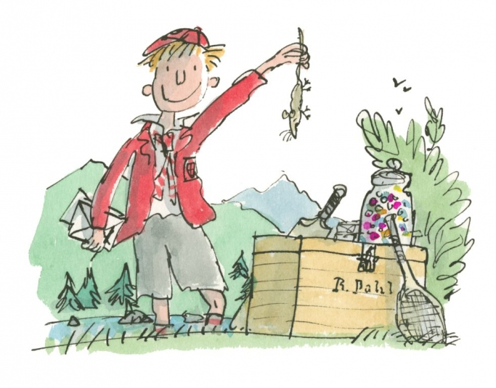  - Exposition At the start of the story, the writer describes…  - Inciting incident (catalyst) The inciting incident occurs when the boys find…  - Rising action Tension starts to build when…  - Climax The highest point of action in the story is when…  - Resolution At the end of the story, the boys… The protagonist feels…  Challenge:  - Who is the protagonist?  - Who is the antagonist?  - How has the protagonist changed by the end of the story?
Week 4: Plot – Writing
Challenging question: How can I plot my own story using the Five Act Structure?

Do now: Think of the greatest prank you ever pulled. What happened?
___________________________________________________________________________
___________________________________________________________________________
For today’s task, you are going to be plotting your own story based on your own elaborate prank. However, we need to exaggerate to make it a bit more exciting. When writers exaggerate for dramatic effect (and they do this a lot) it is called hyperbole!

Hyperbole = from the Ancient Greek [hyper] meaning beyond and [ballo] meaning to throw.
An Ok Prank
The Greatest Prank Ever
Now, you need to be able to answer these questions about your story before you begin.
- Who is the protagonist, the hero? (I presume this is you, but it could be a character from your imagination).
- Who is the antagonist, the bad guy? (Parent, teacher, annoying sibling?)
- What made you decide to pull a prank, or “get your own back”?
- What was the funniest part of the prank?
- What happened at the end?

Task 1: Summarise your story in five sentences –
- ___________________________________________________________
___________________________________________________________
- ___________________________________________________________
___________________________________________________________
- ___________________________________________________________
___________________________________________________________
- ___________________________________________________________
___________________________________________________________
- ___________________________________________________________
___________________________________________________________

Task 2: Plot your story.
- Exposition (set up) | Who is the main character? Where are they at the start of the story? What do they want?
- Catalyst/ inciting incident | Why does your character decide to prank someone?
- Rising action | What happens in the build-up to the prank?
- Climax | What is the most dramatic thing that happened?
- Resolution | How does your story end? How does the protagonist feel? Has the “bad guy” learnt their lesson?
Challenge: There is now space for you to write your own short story, if you choose.
________________________________________________________________________________________________________________________________________________________________________________________________________________________________________________________________________________________________________________________________________________________________________________________________________________________________________________________________________________________________________________________________________________________________________________________________________________________________________________________________________________________________________________________________________________________________________________________________________________________________________________________________________________________________________________________________________________________________________________________________________________________________________________________________________________________________________________________________________________________________________________________________________________________________________________
________________________________________________________________________________________________________________________________________________________________________________________________________________________________________________________________________________________________________________________________________________________________________________________________________________________________________________________________________________________________________________________________________________________________________________________________________________________________________________________________________________________________________________________________________________________________________________________________________________________________________________________________________________________________________________________________________________________________________________________________________________________________________________________________________________________________________________________________________________________________________________________________________________________________________________
____________________________________________________________________________________________________________________________________________________________________________________________________________________________________________________________________________________________________________
Week 5: Character – Heroes
Challenging question: How can I create my own believable hero?
Do now: What do you look for in a friend?
Loyal
A good friend

How can I create a believable main character?
The main character in a story is also known as the hero, or protagonist. However, this does not mean that your protagonist needs to have stereotypically “heroic” qualities. They do not need to be exceptionally brilliant, or have magic powers.
Think of your protagonist as being like a best friend: someone you can count on and enjoy spending time with.
You want your main character to be relatable.

What does the word mean?  You can relate to someone, or understand them, because you share similar things in common. | How can I use it in a sentence?  The character of Harry Potter is relatable to many children, as he starts off as an ordinary boy, just wanting to be loved.  Relatable
From the word related,  meaning to have a connection.  What is the etymology? | likeable, believable  sympathetic, credible, in common,  plausible,  Can I think of any synonyms?

Think about characters in books or films you have enjoyed. What do you like about them?

What does a relatable protagonist look like?
S. E. Hinton wrote The Outsiders (1967) when she was just sixteen. The novel is about two rival gangs, the Greaser and the Socs. Ponyboy Curtis is a plausible main protagonist, because he acts and talks like many real teenagers at the time.

Task 1: Read the extract from The Outsiders by S. E. Hinton.
Think about Ponyboy’s narrative voice (the way he speaks in the text).
When I stepped out into the bright sunlight from the darkness of the movie house, I had only two things on my mind: Paul Newman and a ride home. I was wishing I looked like Paul Newman--- he looks tough and I don't--- but I guess my own looks aren't so bad. I have light-brown, almost-red hair and greenish-gray eyes. I wish they were more gray, because I hate most guys that have green eyes, but I have to be content with what I have. My hair is longer than a lot of boys wear theirs, squared off in back and long at the front and sides, but I am a greaser and most of my neighborhood rarely bothers to get a haircut. Besides, I look better with long hair.
I had a long walk home and no company, but I usually lone it anyway, for no reason except that I like to watch movies undisturbed so I can get into them and live them with the actors. When I see a movie with someone it's kind of uncomfortable, like having someone read your book over your shoulder. I'm different that way. I mean, my second-oldest brother, Soda, who is sixteen-going-on-seventeen, never cracks a book at all, and my oldest brother, Darrel, who we call Darry, works too long and hard to be interested in a story or drawing a picture, so I'm not like them. And nobody in our gang digs movies and books the way I do. For a while there, I thought I was the only person in the world that did. So I loned it.
Soda tries to understand, at least, which is more than Darry does. But then, Soda is different from anybody; he understands everything, almost. Like he's never hollering at me all the time the way Darry is, or treating me as if I was six instead of fourteen. I love Soda more than I've ever loved anyone, even Mom and Dad. He's always happy-go-lucky and grinning, while Darry's hard and firm and rarely grins at all. But then, Darry's gone through a lot in his twenty years, grown up too fast. Sodapop'll never grow up at all. I don't know which way's the best. I'll find out one of these days.
Anyway, I went on walking home, thinking about the movie, and then suddenly wishing I had some company. Greasers can't walk alone too much or they'll get jumped, or someone will come by and scream "Greaser!" at them, which doesn't make you feel too hot, if you know what I mean. We get jumped by the Socs. I'm not sure how you spell it, but it's the abbreviation for the Socials, the jet set, the West-side rich kids. It's like the term "greaser," which is used to class all us boys on the East Side.
We're poorer than the Socs and the middle class. I reckon we're wilder, too. Not like the Socs, who jump greasers and wreck houses and throw beer blasts for kicks, and get editorials in the paper for being a public disgrace one day and an asset to society the next. Greasers are almost like hoods; we steal things and drive old souped-up cars and hold up gas stations and have a gang fight once in a while. I don't mean I do things like that. Darry would kill me if I got into trouble with the police. Since Mom and Dad were killed in an auto wreck, the three of us get to stay together only as long as we behave. So Soda and I stay out of trouble as much as we can, and we're careful not to get caught when we can't. I only mean that most greasers do things like that, just like we wear our hair long and dress in blue jeans and T-shirts, or leave our shirttails out and wear leather jackets and tennis shoes or boots. I'm not saying that either Socs or greasers are better; that's just the way things are.
Gray = the American spelling of grey.
Neighborhood = the American spelling of neighbourhood.
Mom = the American word for Mum.

List four things you learn about Ponyboy:
- ___________________________________________________________

- ___________________________________________________________

- ___________________________________________________________

- ___________________________________________________________

Task 2: Answer the questions in full sentences
- What does Ponyboy look like?
___________________________________________________________________
- What does he like to do for fun?
___________________________________________________________________
- Who is the most important person in his life?
___________________________________________________________________
- What does Ponyboy wear?
___________________________________________________________________
- What do you think his personality is like? Why?
___________________________________________________________________

Does my main character need to be perfect?
NO! Nobody’s perfect, remember. This is why you must always give your protagonist a flaw. Look at Ponyboy: we know that he’s a loner and gets in trouble sometimes. The more flawed your characters are, the more human and relatable they become.
Flaw = a weakness or mistake. e.g. a character might have a quick temper, they might be a loner, or find it difficult trusting others.

Task 3: Now, it is time for you to create your own protagonist.
Name and age

Appearance

Family and background

Strengths

Weaknesses/flaws

If you want to, you can draw your main character here:
Week 5: Character – Villains
Challenging question: How can I create my own engaging villain?

Do now: How many synonyms (other words) for good and bad can you think of?
good | bad

A better word for saying bad or evil is malevolent.
What does the word mean?  Being cruel and wanting to inflict pain or harm or others. | How can I use it in a sentence?  Lady Macbeth is presented as a malevolent character as she persuades her husband to kill the king.  Malevolent
From the Latin (mal-)  meaning bad or wrong. There is a 15th Century book on witchcraft called Malleus Maleficarum.  What is the etymology? | Malicious, vindictive, cruel,  spiteful, wicked, devious, nefarious  Can I think of any synonyms?

The villain or “bad guy” in your story is known as the antagonist. This is the character who causes problems, or conflict, for the protagonist.
Remember, people are usually evil for a reason. If you antagonist is a bully, you must consider and understand why they behave the way they do. Every antagonist is the hero in their own story.
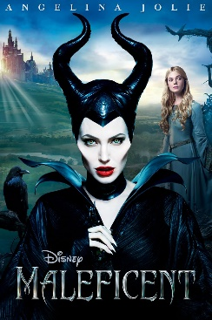
Challenge: What villains can you think of from film/literature?

Task 1: Read the description of Professor Snape from Harry Potter and the Philosopher’s Stone by J. K. Rowling.
Potions lessons took place down in one of the dungeons. It was colder here than up in the main castle, and would have been quite creepy enough without the pickled animals floating in glass jars all around the walls.
Snape, like Flitwick, started the class by taking the roll call, and like Flitwick, he paused at Harry's name.
"Ah, Yes," he said softly, "Harry Potter. Our new -- celebrity."
Draco Malfoy and his friends Crabbe and Goyle sniggered behind their hands. Snape finished calling the names and looked up at the class. His eyes were black like Hagrid's, but they had none of Hagrid's warmth. They were cold and empty and made you think of dark tunnels.
"You are here to learn the subtle science and exact art of potionmaking," he began. He spoke in barely more than a whisper, but they caught every word -- like Professor McGonagall, Snape had the gift of keeping a class silent without effort. "As there is little foolish wand-waving here, many of you will hardly believe this is magic. I don't expect you will really understand the beauty of the softly simmering cauldron with its shimmering fumes, the delicate power of liquids that creep through human veins, bewitching the mind, ensnaring the senses... I can teach you how to bottle fame, brew glory, even stopper death -- if you aren't as big a bunch of dunderheads as I usually have to teach."
More silence followed this little speech. Harry and Ron exchanged looks with raised eyebrows. Hermione Granger was on the edge of her seat and looked desperate to start proving that she wasn't a dunderhead.
"Potter!" said Snape suddenly. "What would I get if I added powdered root of asphodel to an infusion of wormwood?”
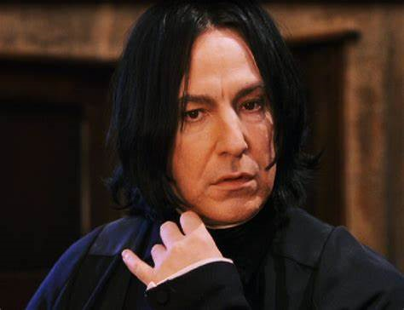
Powdered root of what to an infusion of what? Harry glanced at Ron, who looked as stumped as he was; Hermione's hand had shot into the air.
"I don't know, sir," said Harry.
Snape's lips curled into a sneer.
"Tut, tut -- fame clearly isn't everything."
[*dunderhead = stupid person, idiot]

Now answer the comprehension questions in full sentences:

- What colour are Snape’s eyes and what do they make you think of?
_________________________________________________
- What is Snape’s voice like? Why do you think he speaks like this?
________________________________________________
- How do the children in the class react when Snape stops talking? What does this suggest about him as a teacher?
________________________________________________
________________________________________________
- Do you think Snape likes his job? What gives you this impression?
__________________________________________________
__________________________________________________
- Why do you think J. K. Rowling used the word sneer to describe the way Snape smiles?
__________________________________________________
__________________________________________________
- Do you think Snape likes Harry? Why/why not?
__________________________________________________
__________________________________________________
Challenge: How does the setting reflect (link to) Snape’s personality?
_____________________________________________________
_____________________________________________________
Task 3: Design your own villain!
Name and age
Appearance
Strengths
Weaknesses
Backstory
(what made them this way?)
You may draw your villain if you wish!

