Summer Transition Booklet –
History and Geography

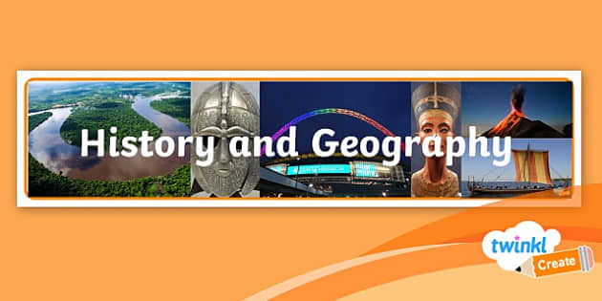
Year 6 into Year 7

Name: _________________

Welcome Message:
Welcome to your History and Geography Summer Work Class of 2027! We are very excited to welcome you to our school in September! In this pack you will find 4 activities to complete over the 6 weeks of the Summer Holidays. It will help you to learn some key vocabulary that will give you a flying start when you join us in September. Please hand this in to your class teacher when you start.
Here is a message from the Head of Geography:
My name is Ms Ribbands and I am Head of Geography and lead the Eco Committee. I love teaching Geography at DTA, I’m always incredibly impressed with the places you have visited, and use your experience of the world in our lessons. Geography means understanding places and people, not just naming capitals cities. In our curriculum we focus on how the world is changing for you, constantly referring to recent global events, like the flooding in India or the earthquake in Afghanistan of Summer 2022. We have a fantastic Geography Games club that is open to all year7’s, I look forward to seeing you all there.

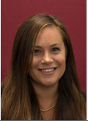

Here is a message from the Head of History:
My name is Miss Williams and I am a History teacher here at Dean Trust Ardwick. I can’t wait to have a new group of historians join us in September. At DTA we love to learn about the history of our pupils and you will notice in our history curriculum, we study a lot of history from many of our pupils’ home countries. We study medieval African kingdoms, ancient Islamic empires, the rise and fall of the Empire in Australia, America, India and Africa as well as the cold war in Somalia and Afghanistan. We love the knowledge that our pupils bring to these lessons which helps everyone else have a greater understanding of world history!

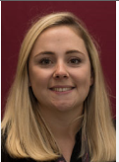

Contents:

Week | Task | Completed
1 | What are maps and how do we use them?
2 | How rich and religious was England before 1066?
3 | What does Manchester look like on a map?
4 | Who should be king?

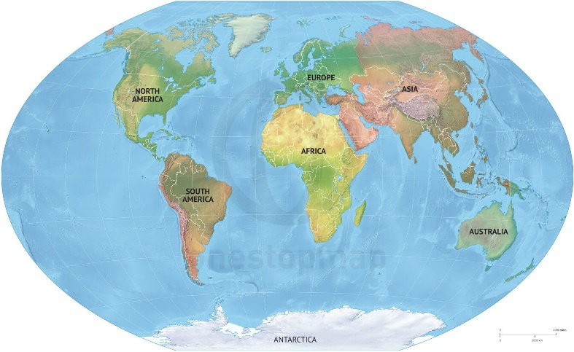
Topic: What are maps and how do we use them?
Retrieval Questions:
1. Define Human Geography
2. Define Physical Geography
3. Geography is just where countries are True or False?
4. List 3 countries in Europe
5. Is Manchester in the North or South of England?
1.
2.
3.
4.
5.
Maps are basically an image of a place, seen from above. Using different symbols, maps allow you to see where you are in a particular place, and where other things are in relation. You can also look at maps of other places, such as countries, to learn about their location in the world.
Maps can be drawn to different levels of detail. For example, they can be as focused as just being a map of a single room, to being a map of a town, country, continent to a map of the whole world.
Learning about maps in geography develops your knowledge of:
- Locational knowledge: Naming and locating the world’s seven continents and five oceans; identifying characteristics of four countries and capital cities. This is specifically where our geography maps can come in handy.

- Place knowledge: Understand geographical similarities and differences

- Geographical skills and fieldwork: Use world maps to identify the United Kingdom and its countries; identify continents and oceans; use simple compass directions and locational and directional language, along with features on a map
The word ‘continents’ has been mentioned many times in the paragraphs above, but what does it mean? There are 7 continents in our world these can be seen on the world map below.
A continent is a very large area of land that consists of several countries (apart from Antarctica). We live in the United Kingdom, which is in Western Europe, can you circle Europe on the map?

If you can mark where the United Kingdom is on the map, I’ll be very impressed, I might even give out some merits!.
Now lets look at another map of the world, this time it has lots of lines on it. These are called lines of latitude and longitude.

Latitude lines are the lines that run horizontally around the world – allows you to measure a location North or South of the Equator.

Longitude lines are the lines that run vertically from North to South around the world – measured from the Prime Meridian in Greenwich.

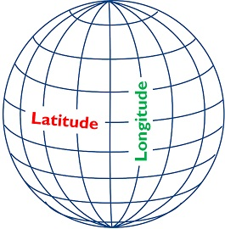
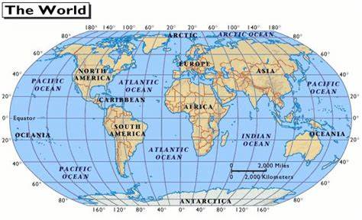
We use these lines of latitude and longitude to help us locate where a place is in the world.
Key terminology:
- Prime Meridian – A line of longitude that runs through Greenwich, UK.
- Horizontal – Across
- Vertical – Upright
Extended Questions:
- What does place knowledge help us understand?
- What is a map?
- Name all 5 Oceans in the world using the maps above.
- What do the lines of latitude allow us to measure?
- Why do we use lines of latitude and longitude?
1.

2.

3.

4.

5.

Topic: How rich and religious was England before 1066?
Retrieval Questions:
- Who were the Anglo-Saxons?
- What were the Middle Ages?
- What is a Monarch?
- What religion did the Anglo-Saxons follow?
- Give the name of a county which was named after the Anglo-Saxons.
1.
2.
3.
4.
5.
Key term | Definition | Concrete example/Fact
Evidence | Facts or information indicating whether a belief or proposition is true or valid. | Suspects blood, fingerprints
Chronicles | A factual written account of important or historical events in the order of their occurrence | Anglo-Saxon Chronicle

How rich was England?
The rich were very rich and the poor were very poor. Out of every 100 people, about two were rich. They made their money from the land they owned (because people paid them rent to live on it) or from trading in all sorts of goods. Some men made so much money they built fabulous homes and Churches and lived in luxury. By contrast, life was very hard for the poor. Each family had to grow its own food and there no shops like today where we can buy more if we run out. If the harvest was bad, a family might have to eat roots, leaves, wild berries, and any creatures they could catch.

Were the people religious?
The simple answer is yes. Everyone was a Christian and went to church. In monasteries monks kept huge official diaries called chronicles. They wrote about religion, politics, history, towns, kings, gossip and even the weather.
How do we know all this?
We certainly don’t know everything about England at this time. However, we know enough to give us a good idea about what life was like. We can look at a number of different sources from the time, which allows us to build up a picture of everyday life-paintings, churches, and other buildings, coins, weapons, drawings, jewellery, and books written at the time. These sources are evidence of life in England in 1066.
Task:
Use the information on this page to match up the start of each sentence (List A) with the correct ending (List B). Write the sentences out below.
- List A:  - At this time everyone was…  - Monks often kept a record of important events…  - England was well known in Europe for its natural resources such as...  - Most people were poor and …  - There were some rich people who made their money by… | List B:  …renting out their land or by trading goods.  …tin, cloth, silver and lead.  …Christian and went to Church  …in books called ‘chronicles’  …grew their own food

Topic: What does Manchester look like on a map?
Retrieval Questions:
1. Which continent is Manchester in?
2. Is Manchester north or south of the equator?
3. Where is the UK is Manchester?
4. What are the names of the nearest mountains to Manchester?
5. Why are symbols important on an map?
1.
2.
3.
4.
5.
Map of Manchester: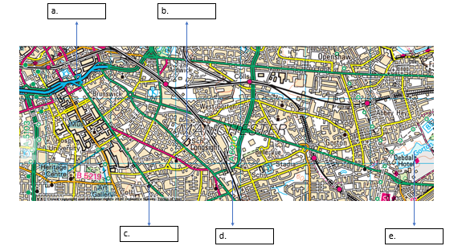
The map above is of Ardwick, an inner-city area south east of the city centre. It shows a variety if roads from motorways in blue to A and B roads. Stockport road is a main road and represented in green. In this area there is a huge range of services from schools, museums, churches, hospitals and train stations.

Debdale reservoir is in the east of Manchester, this is a reactional site where there is a cycle path, park and yacht club.
Extended Questions:
- What are the features at the points below

- Name 2 physical features shown on the map.

- Name 2 human features shown on the map.

- What is good about this map?
- How do you think this map could be improved?
- Draw a map of your local area with 10 features (mixture of human and physical.

Topic: Who should be King?
Retrieval Questions:
1. What is an heir?
2. What was the most important building in a medieval village?
3. What is a villein?
4. Name a job of a medieval villein
5. What was society like in Britain in 1066?
1.
2.
3.
4.
5.
Key term | Definition
Witan | They were the council of the Anglo-Saxon. Their duty was to advise the king on all matters on which he chose to ask its opinion.
Consecrated | (of a church or land) having been made or declared sacred
Contender | A person or group competing with others to achieve something

It was January 1066 and the King of England, Edward the Confessor had died!
Big problem!! Edward did not have any children, meaning there was no heir to the throne. In 1066, to become a King you had to be one of these:
- A blood relative of the King
- Have been chosen by the previous King to be the next King
- Been accepted by the Witan, a very important council of England’s most important nobles
However, the problem of there being no heir to the throne soon became solved as:
There were now three contenders to be KING.
1) Harold Godwinson
2) Harald Hardrada
3) William. Duke of Normandy

Harold Godwinson
He was brother of King Edward the Confessor’s wife. He was son of Earl Godwin, the most powerful noble in England.
He was supported by a special council of nobles called the Witan who had agreed to making him king. He was born and bred in England and popular with ordinary people. He had been involved in running the country for years.
He had experience of running government and the army. However, he didn’t have a direct blood link to the king. Nevertheless, the king had extended his hand to him as he died as a possible sign that he was his chosen heir (successor). But then, who’s say the king was really in a fit state to know whom he was talking to?

Harald Hardrada
Harald was king of Norway and a direct descendant of the kings of England. His grandfather, King Canute, had been King of England. He was an excellent warrior and usually won any battle he got himself into. He managed to raise a lot of money for his wars through taxation. He wanted the wealth and riches that England had. He was supported by Tostig Godwinson, Harold’s brother. A downside was that he was very unpopular, but very powerful. His name alone was enough to strike fear into the hearts and minds of his enemies. He was a Viking warrior, and that was all his opponents needed to know!

William Duke of Normandy
William was the cousin of Edward the Confessor. He claimed that Edward had promised him the throne in 1051, but English supporters of Harold challenged this. He had been a very successful ruler of Normandy and he thought he could do an equally good job for England. In Normandy he was only Duke whereas in England he would be King!
He was a good organiser and was determined to get what he wanted. A downside was that he came from a very ‘ordinary’ background – his mother’s parents had been tanners (leather workers) and his enemies often teased him about this.

Harold Godwinson
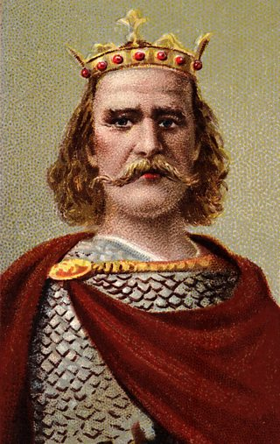 | 1. Nationality:  2. Was he related to King Edward?  3. Did anybody promise him the crown and why?  4. Did the strong people of England like him?  5. Were there any other reasons why he should be king?
William, Duke of Normandy
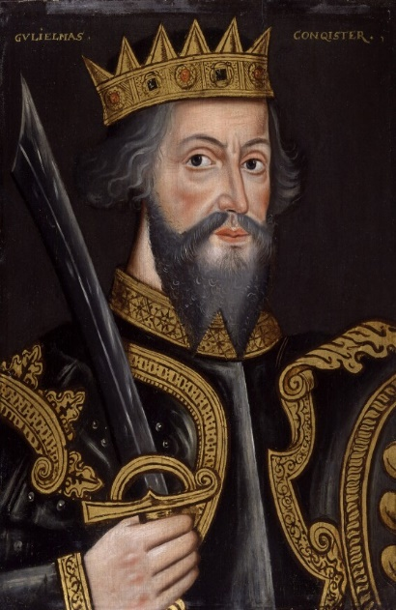 | 1. Nationality:  2. Was he related to King Edward?  3. Did anybody promise him the crown and why?  4. Did the strong people of England like him?  5. Were there any other reasons why he should be king?
Harald Hardrada
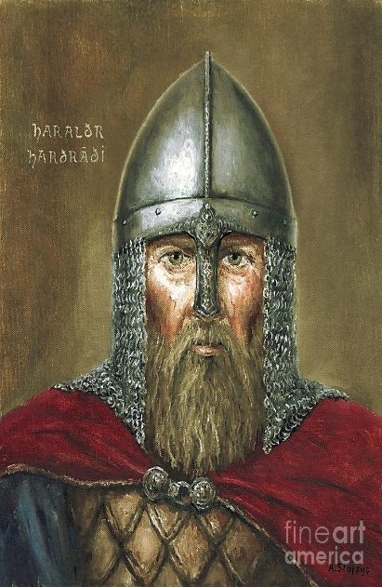 | 1. Nationality:  2. Was he related to King Edward?  3. Did anybody promise him the crown and why?  4. Did the strong people of England like him?  5. Were there any other reasons why he should be king?

See you in September!

