Summer Transition Booklet –
Physical Education

Year 6 into Year 7

Name: ______________________________

Welcome Message:
Here is a message from the Head of PE:
My name is Miss Murphy and I am Head of Physical Education here at Dean Trust Ardwick.
Here in the PE faculty, we cannot wait to welcome you all in September and to see if we have any sporting superstars in the making. During your time in PE at DTA, you will learn about and participate in a variety of sporting activities – but there is more to sport than just the physical skills. We also teach you to develop your cognitive skills and social skills too so you can fulfill your potential and thrive!
From the extra-curricular clubs, to being on the school sports teams, to being a sports leader or a member of the sports council – we have lots to offer you here at DTA!
Have a great summer everyone! We look forward to meeting you all in September! And remember…stay active!

Our recommendations to you:
Children and young people need to do 2 types of physical activity each week:
- aerobic exercise
- exercises to strengthen their muscles and bones

Children and young people aged 5 to 18 should:
- aim for an average of at least 60 minutes of moderate or vigorous intensity physical activity a day across the week
- take part in a variety of types and intensities of physical activity across the week to develop movement skills, muscles and bones
- reduce the time spent sitting or lying down and break up long periods of not moving with some activity. Aim to spread activity throughout the day

To help you complete the recommendations above, here are a few suggestions/tasks to keep you active and less bored during the summer holidays…

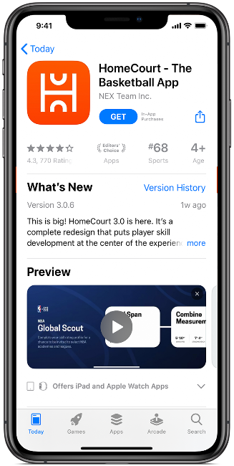
Suggestion 1:
Download the ‘Homecourt’ app

Improve your skills—anytime, anyplace. Train smarter with instant feedback, engage in fun and immersive drills, and compete virtually with players around the world.

Suggestion 2:
Download the ‘Swork-It Kids’ app
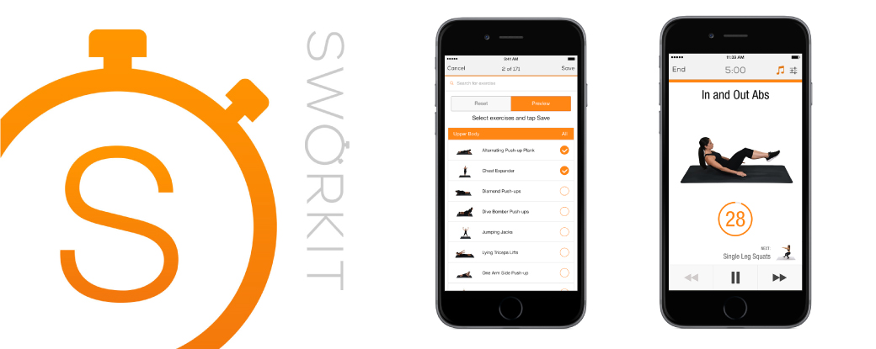
An app that introduces children to strength, agility, flexibility, and balance exercises. Easily customize activities and the length of your workout. This app shows children demonstrating activities with proper technique, making it easy for you to learn and follow along.

Use the free apps above to workout in a fun and engaging way!

A PE challenge a day for 30 days!
How many can you do? Tick them off as you go along…

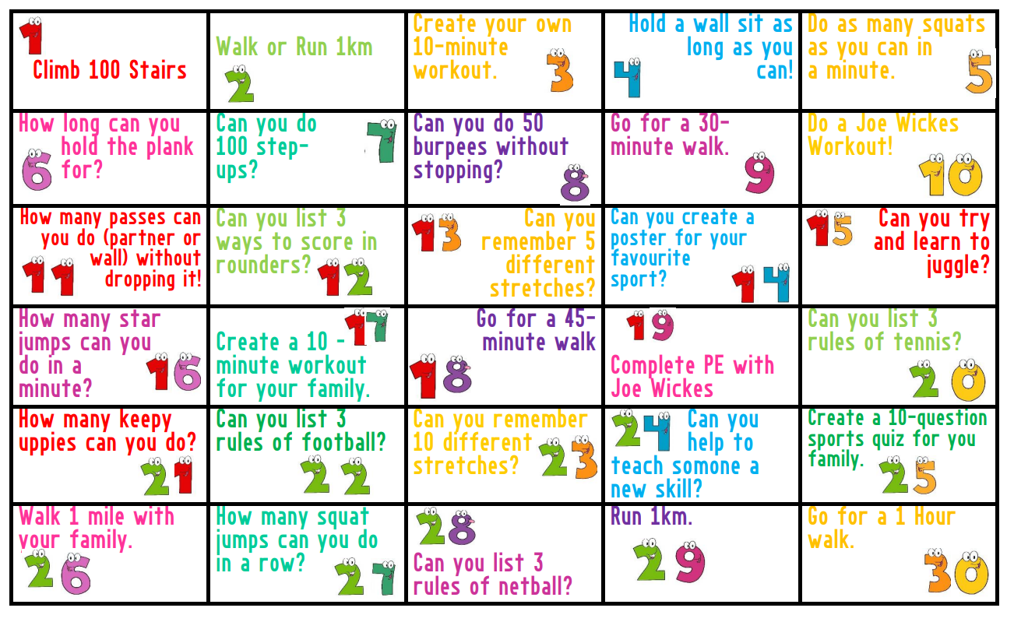

Have a go at a workout!
Spell your name to get the exercise you need to do plus how many of each exercise you should do.

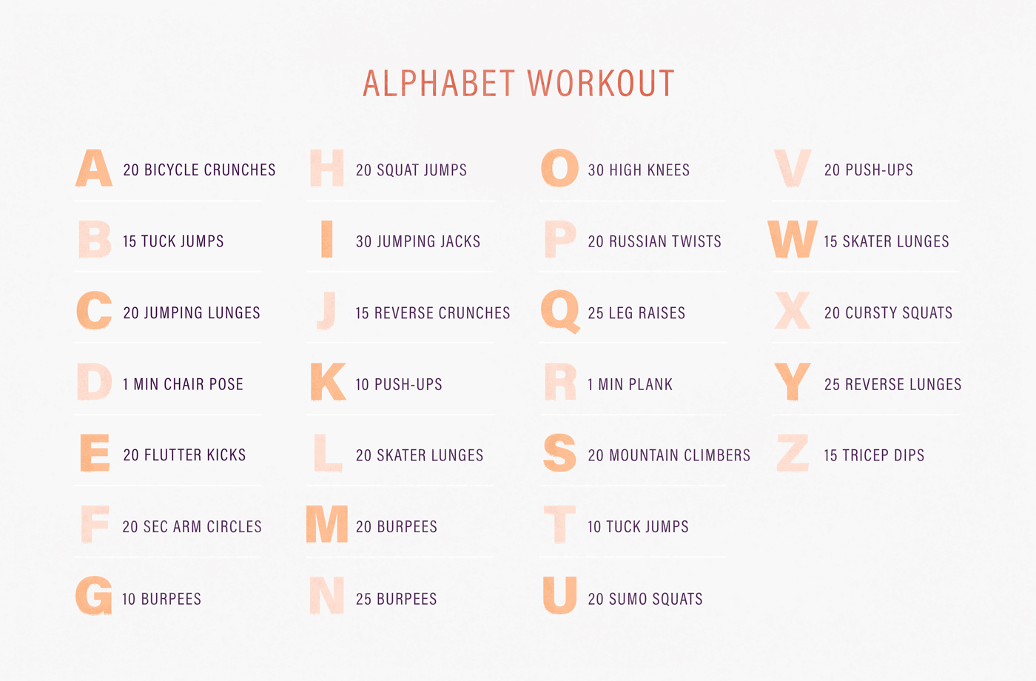

TASK: Look, Cover, Write, Check
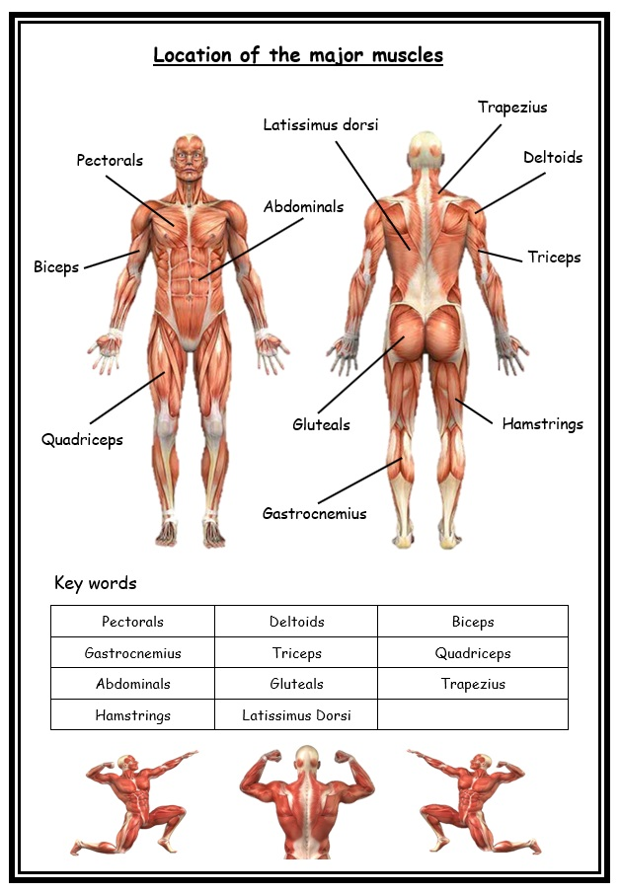
Can you memorise the names and locations of some of the major muscles that you will learn about in Y7 PE lessons? On the next page, see if you can fill in the names without looking back.
How many of the muscle names can you remember? Fill in the blanks, then look back to see how many you got right.
My sporting profile:
Do you like PE? ________________________________________________

What did you like or not like about PE at primary school? ________________________________________________________________________________________________________________________________________________________________________________________________________________________________________________________________________________________________________________________________________________________________________________________________

My favourite sport to play is:
________________________________________________________________

My favourite sport to watch is:
________________________________________________________________

My sporting idol is:______________________________________________
because_______________________________________________________________________________________________________________________________________________________________________________________________________________________________________________________

My favourite team is:____________________________________________

I am looking forward to PE at DTA because ________________________________________________________________________________________________________________________________________________________________________________________________________________________________________________________________
Here in the PE department, we’re intrigued to know your thoughts….
Why is Physical Education important and why should everyone value it as a subject?
________________________________________________________________________________________________________________________________________________________________________________________________________________________________________________________________________________________________________________________________________________________________________________________________________________________________________________________________________________________________________________________________________________________________________________________________________________________________________________________________________________________________________________________________________________________________________________________________________________________________________________________________________________________________________________________________________________________________________________________________________________________________________________________________________________________________________________________________________________________________________________________________________________________________________________________________________________________________________________________________________________________________________________________________________________________________________________________________________________________________________________________________________________________________________________________________________________________________________________________________________________________________________________________________________________________________________________________________________________________________________________________________________________________________________________________________________________________________________________________________________________________________________________________________________________________________________________________________

