Summer Transition Booklet
Social Sciences

Year 6 into Year 7

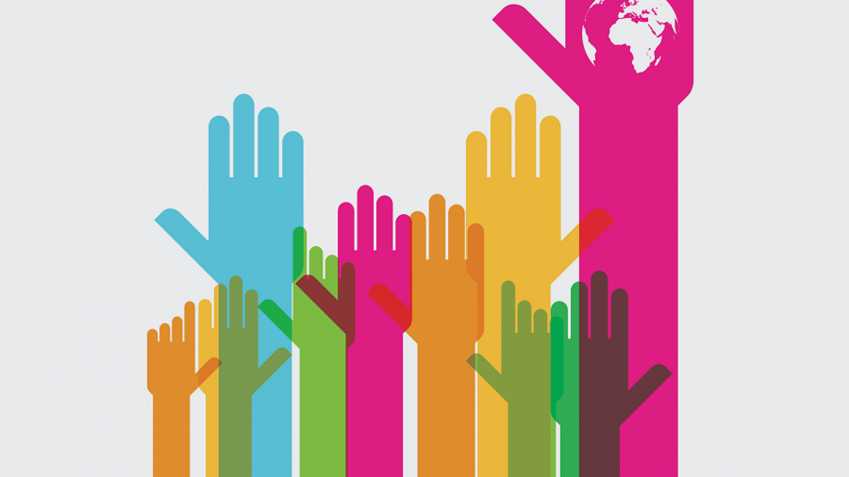

Name: ______________________________

Welcome to Social Sciences.
Here is a message from Miss Bostock:
My name is Miss Bostock and I am Head of RSHE and Citizenship at Dean Trust Ardwick. I also teach Child Development in Year 10 and 11. This combination of subjects, together, we call the Social Sciences. I have been at Dean Trust Ardwick since 2016 and have taught other subjects such as English, Music and Drama. However, the Social Sciences are my expertise and passion as I think it is important that every pupil here grows up to be happy, healthy and kind.
RSHE stands for Relationship, Sex and Health Education. You will learn how to look after your emotional and physical wellbeing, and how to get on well with your friends and family too.
Citizenship is all about the communities we live in; at school, our town, the UK and our place in the world. You will learn how our communities’ function and how you can make them better places to live.
I look forward to meeting you and teaching you!

Contents:

Topic | Task | Completed
RSHE | What is Self Esteem?
Citizenship | What are Human Rights?

RSHE: What is Self Esteem?

How would you describe yourself to someone who doesn’t know you?
____________________________________________________________________________________________________________________________________________________________________________________________________________________________________________________________________________________________________________

I wonder whether you chose to describe your appearance, your hobbies or your personality or a mix of both? Have another think about these different sides to you…
My appearance
My hobbies
My personality
Self-esteem changes. It is how much or little you value yourself. Some times we think we are brilliant and feel proud about who we are. Other times, we can be annoyed or disappointed in ourselves. How we feel about ourselves is our self-esteem.

How do you feel about yourself today?
__________________________________________________________________________________________________________________________________________________________________________________________________________________________________________________________
Knowing what changes our self esteem is important so we can stay in control of our feelings. Make a list of what changes your self esteem:
Things that lower my self esteem | Things that raises my self esteem
Citizenship: What are Human Rights?

Human rights are things that belong to everyone so our lives are happy, healthy and dignified. You do not have to earn your human rights- you have them because you are human!
You do have to use your human rights responsibly.
Your human rights should not be taken away from you, nor should you take away anyone else’s rights.
But what are they?
The United Nations is an organisation that wrote down what our human rights should be. They have another list that is specific to children- sometimes children need more protection than adults.
Look at the rights on the next page. Which ones apply to you and why?

- Circle 5 human rights that you think are the most important to you.

- Write down how your family, friends and school can help protect those rights and make sure you always have them.

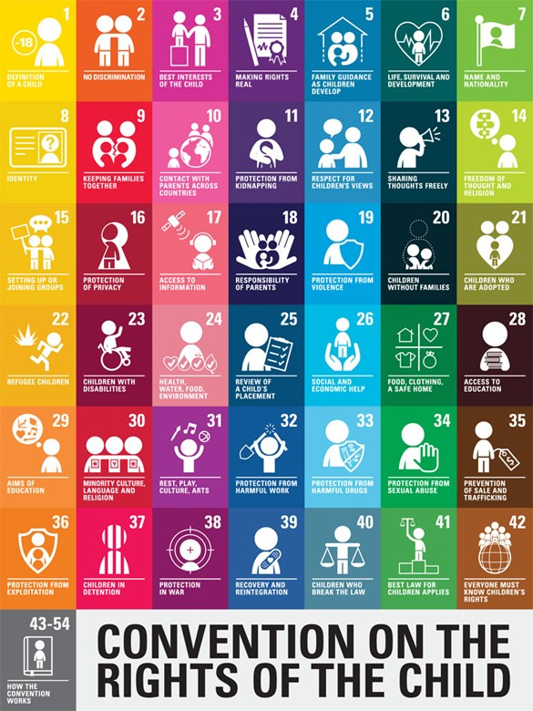

How my family can protect my human rights: ________________________________________________________________________________________________________________________________________________________________________________________________________

How my friends can protect my human rights: ________________________________________________________________________________________________________________________________________________________________________________________________________

How school can protect my human rights: ________________________________________________________________________________________________________________________________________________________________________________________________________

How I can protect other people’s human rights: ________________________________________________________________________________________________________________________________________________________________________________________________________

At Dean Trust Ardwick, we all have a responsibility to make sure everyone is safe and happy. That is why we recognise the protected characteristics that make us all unique. When you attend DTA, you will be expected to show respect and accept everyone no matter their

- Sex (girl/boy)
- Gender transition (non-binary/trans)
- Sexuality (gay/ bisexual/pansexual)
- Ability (disabled/learning difficulties)
- Religion
- Race (nationality/skin colour)
- Age (all year groups/adults)
- Family unit (children in care/adopted/single parent family/same-sex parents)

There are consequences for anyone who shows disrespect based on these qualities. That is because they are protected by law.

